|  |  |  |  |
| --- | --- | --- | --- |
| NAME: | Sarcol, Joshua S | DATE: | 10/08/2023 |

PRACTICE EXERCISE # 5.2

# LE 5.21 Multiplication Table

The program will ask the user to input the number of rows and columns the table should have and display the multiplication table on screen. Use tab for the spacing between numbers horizontally.

## Pseudocode: LE 5.21 Multiplication Table

START

1. INITIALIZE column, row, and result as integer
2. PROMPT and GET column and row
3. PRINT *tab*
4. FOR (i = 1; i <= column; i++)
   1. PRINT i
5. ENDFOR
6. PRINT *newline*
7. FOR (i = 1; i <= row; i++)
   1. FOR (int j = 0; j <= column; j++)
      1. IF j == 0
         1. PRINT i
      2. ELSE
         1. CALCULATE result, result = i * j
         2. PRINT result
      3. ENDIF
   2. PRINT newline
   3. ENDFOR
8. ENDFOR

STOP

## Flowchart: LE 5.21 Multiplication Table

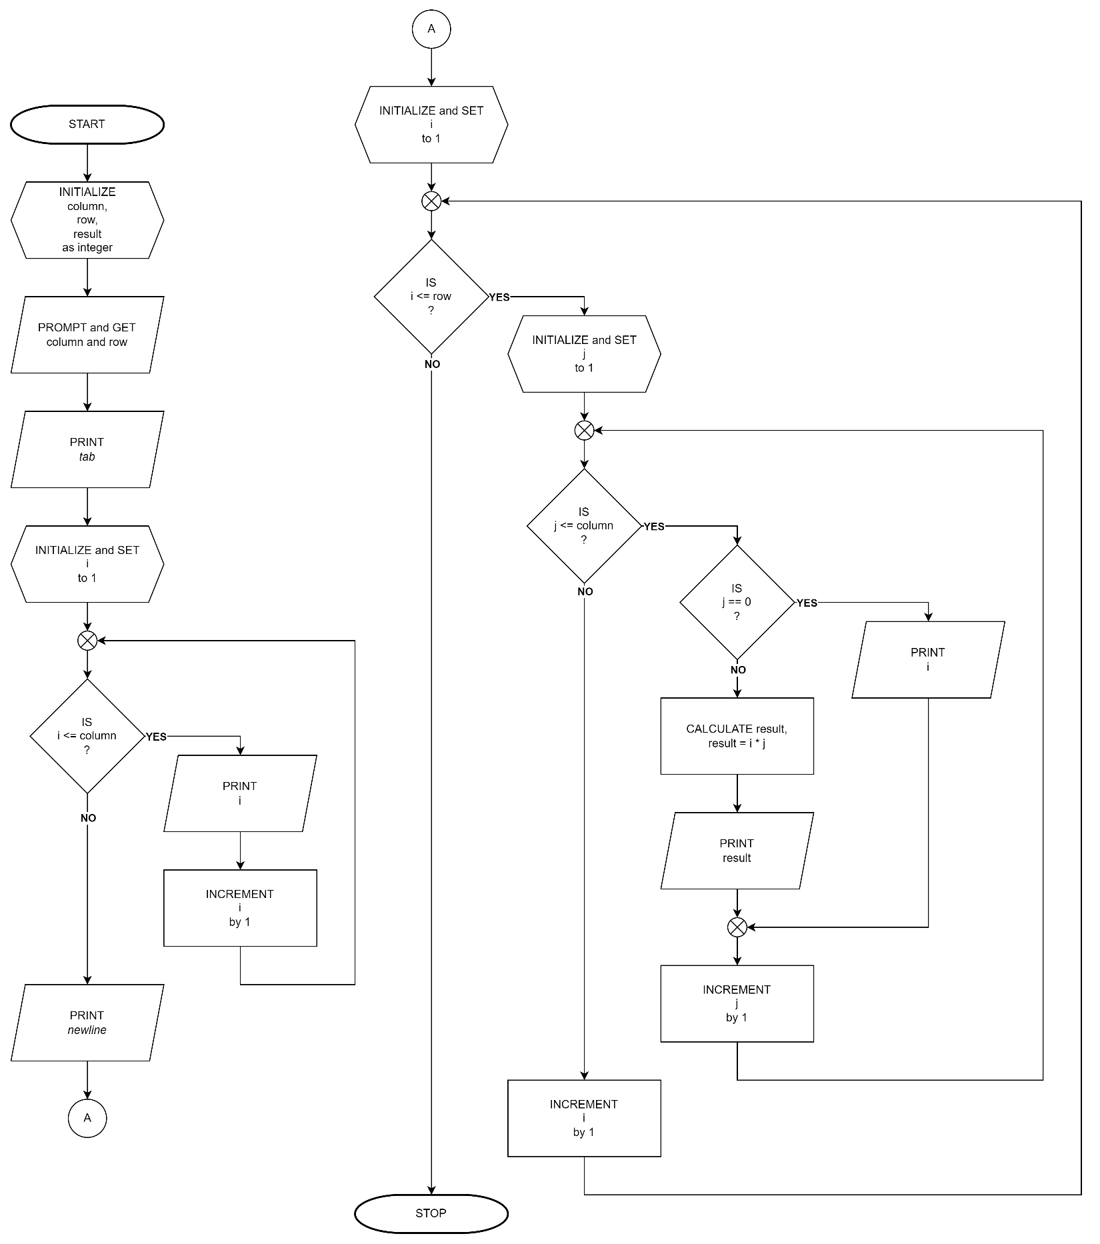

# LE 5.22 Pyramid

Create a program that would display like this

Example output:

Enter a value for N: 5

1

121

12321

1234321

123454321

## Pseudocode: LE 5.22 Pyramid

START

1. INITIALIZE pyramidHeight and result as integer
2. PROMPT and GET pyramidHeight
3. FOR (i = 1; i <= pyramidHeight; i++)
   1. FOR (j = - (pyramidHeight – 1); j <= pyramidHeight; j++)
      1. CALCULATE result, result = i - |j|
      2. IF result > 0
         1. PRINT result
      3. ELSE
         1. PRINT space
      4. ENDIF
   2. ENDFOR
   3. PRINT newline
4. ENDFOR

STOP

## Flowchart: LE 5.22 Pyramid

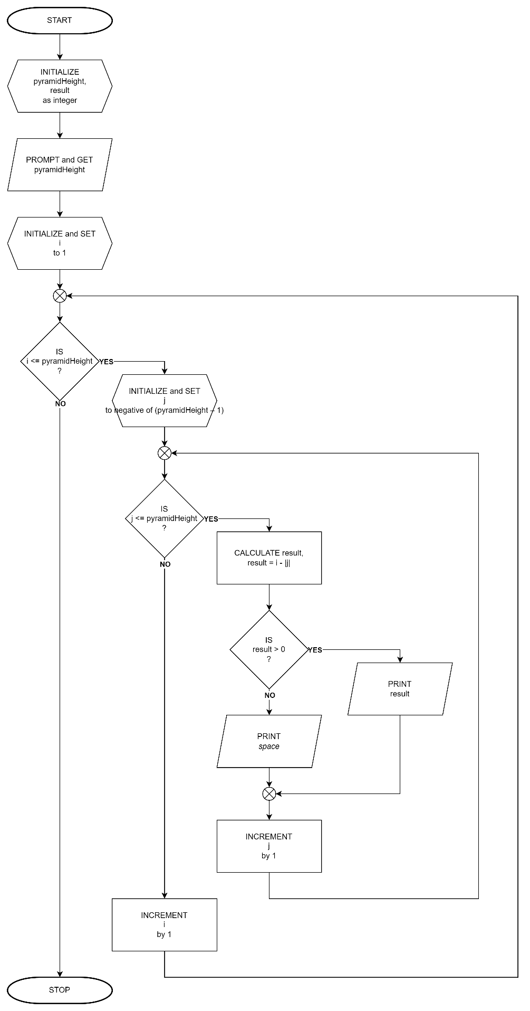

# LE 5.23 Fibonacci Series

Create a program that will display the 1-N value of the Fibonacci sequence. Use a space for the spacing between numbers horizontally.

Example Output:

Enter limit: 10

Fibonacci sequence: 1 1 2 3 5 8 13 21 34 55

## Pseudocode: LE 5.23 Fibonacci Series

START

1. INITIALIZE terms as integer
2. PROMPT and GET terms
3. PRINT Fibonacci sequence:
4. FOR (i = 1, n = 1, m = 0, o = 0; i <= terms; i++)
   1. PRINT n
   2. COPY value of m to o
   3. COPY value of n to m
   4. CALCULATE n, n = m + n
5. ENDFOR

STOP

## Flowchart: LE 5.23 Fibonacci Series

